PIZZA SALES SQL QUERIES
- KPI’s
- Total Revenue:

select sum(total_price) AS Total_Revenue from pizza_sales;

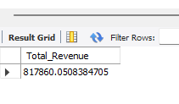
- Average Order Value:

select sum(total_price)/count( distinct order_id) AS Average_Order_Value from pizza_sales;

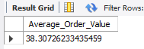

- Total Pizzas Sold

select sum(quantity) AS Total_Pizza_Sold from pizza_sales;

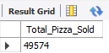

- Total Orders

select count(distinct order_id) as Total_Orders from pizza_sales;

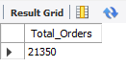

- Average Pizzas Per Order

select cast(cast(sum(quantity) AS DECIMAL(10,2)) /CAST(count(distinct order_id) AS DECIMAL (10,2)) as decimal(10,2)) as Average_Pizza_per_order from pizza_sales;

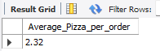

- Daily Trend for Total Orders

alter table pizza_sales add column order_day varchar(50);
update pizza_sales set order_day = DAYNAME(order_date);
select order_day, COUNT(distinct order_id) as total_orders from pizza_sales
group by order_day;

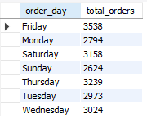

OR

select weekday(order_date) as order_dy, dayname(order_date) as order_D, count(distinct order_id) as total_orders from pizza_sales
group by order_dy, order_D;

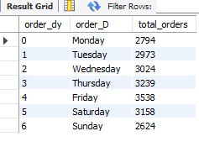

- Hourly Trend for Orders
select hour(order_time), count(distinct order_id) as total_orders from pizza_sales
group by hour(order_time)
order by hour(order_time);
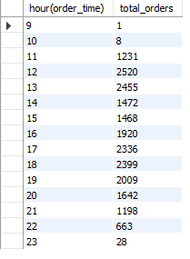

- % of Sales by Pizza Category (January)
select pizza_category, sum(total_price) , cast((sum(total_price)*100)/(select sum(total_price) from pizza_sales where monthname(order_date) = 'january') as decimal (10,2)) as percentage_of_each_pizza_category from pizza_sales
where monthname(order_date) = 'january'
group by pizza_category;

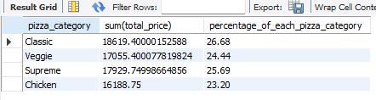

- % of Sales by Pizza Size

select pizza_size, sum(total_price) , cast((sum(total_price)*100)/(select sum(total_price) from pizza_sales) as decimal (10,2)) as percentage_of_each_pizza_size from pizza_sales
group by pizza_size
order by percentage_of_each_pizza_size desc;
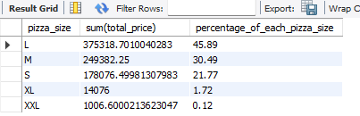

- Total Pizzas Sold by Pizza Category
select pizza_category, sum(quantity) from pizza_sales
group by pizza_category;
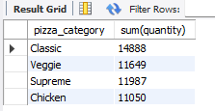

- Top 5 Best Sellers by Total Pizzas Sold

select pizza_name, sum(quantity) as Total_Pizzas_Sold from pizza_sales
group by pizza_name
order by Total_Pizzas_Sold desc LIMIT 5;
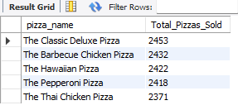

- Bottom 5 Worst Sellers by Total Pizzas Sold

select pizza_name, sum(quantity) as Total_Pizzas_Sold from pizza_sales
group by pizza_name
order by Total_Pizzas_Sold asc LIMIT 5;
